**DEPARTMENT OF ELECTRONICS AND COMMUNICATION ENGINEERING**

**College of Engineering and Technology**

**SRM Institute of Science and Technology**

**MINI PROJECT REPORT**

2022-23 (EVEN Semester)

Lab code & Name : 18ECC302J – Microwave and Optical Communications

Year & Semester : 3rd, 6th

Project Title :Execution of Klopfenstein Taper In python

Lab Supervisor :Dr T RAMA RAO

Team Members : ROHAN GARG(RA2111004010007)

GIRISH NAIDU(RA2111004010037)

YASH CHAUHAN(RA2111004010034)

|  |  |  |  |
| --- | --- | --- | --- |
| Reg. No. | RA2111004010007 | RA2111004010037 | RA2111004010034 |
| Mark split-up |
| Novelty in the project work  (2 marks) |  |  |  |
| Level of understanding (4 marks) |  |  |  |
| Contribution to the project  (2 Marks) |  |  |  |
| Report writing (2 Marks) |  |  |  |
| **Total (10 Marks)** |  |  |  |

Date: 28/04/2024 **Signature of Lab Supervisor**

**TITLE:**

Execution of Klopfenstein Taper In python

**OBJECTIVE:**

The objective of the Klopfenstein tapper in microwave technology is to improve the efficiency of microwave energy transfer from the waveguide to the load by reducing the reflection of microwave energy at the interface between the waveguide and the load. The Klopfenstein tapper is a passive device that is designed to gradually reduce the impedance of the waveguide as it approaches the load, which helps to reduce the amount of microwave energy that is reflected back towards the source. This results in a more efficient transfer of microwave energy to the load, which is particularly important in high-power microwave applications where even small amounts of reflected energy can cause damage to the equipment or reduce the overall efficiency of the system. The Klopfenstein tapper is widely used in microwave heating applications such as industrial processing, food processing, and medical treatments.

**ABSTRACT:**

The Klopfenstein tapper is a passive device used to improve the efficiency of microwave energy transfer from the waveguide to the load by reducing the amount of energy reflected back towards the source. This device is designed to gradually reduce the impedance of the waveguide as it approaches the load, which helps to reduce the amount of microwave energy that is reflected back towards the source. The Klopfenstein tapper is particularly important in high-power microwave applications where even small amounts of reflected energy can cause damage to the equipment or reduce the overall efficiency of the system. The use of the Klopfenstein tapper is widely prevalent in industrial processing, food processing, and medical treatments, where precise control of microwave energy transfer is crucial. This paper provides an overview of the design and applications of the Klopfenstein tapper in microwave technology.

**INTRODUCTION:**

Microwave technology has been widely used in various applications such as industrial processing, food processing, medical treatments, and communication. One of the key challenges in these applications is the efficient transfer of microwave energy from the waveguide to the load. When microwave energy is transmitted through a waveguide, a portion of the energy is reflected back towards the source due to the mismatch between the impedance of the waveguide and the load. This reflected energy can cause damage to the equipment and reduce the overall efficiency of the system. To address this challenge, the Klopfenstein tapper was introduced as a passive device that gradually reduces the impedance of the waveguide as it approaches the load, thereby reducing the amount of reflected energy.

**HARDWARE/SOFTWARE REQUIREMENT & DESCRIPTION:**

Jupyter NOTEBOOK

**BLOCK DIAGRAM/ INTERFACE DIAGRAM:**

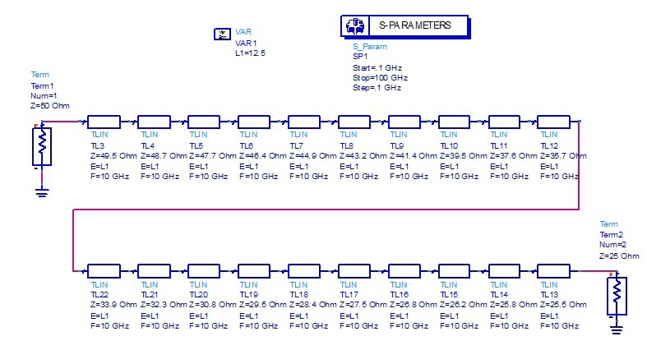

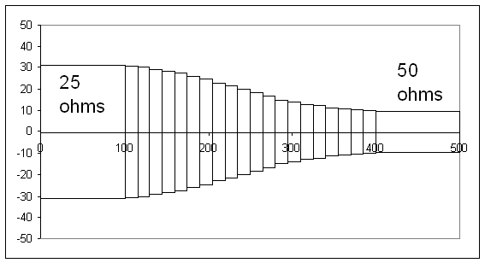

**REALISTIC CONSTRAINTS:**

Firstly, the dimensions of the Klopfenstein tapper should be designed carefully to ensure that it fits precisely into the waveguide and the load. Any mismatch in dimensions can lead to an increase in reflected energy and result in reduced efficiency.

Secondly, the material used for the tapper should have high thermal conductivity and good mechanical stability to withstand the high-power microwave applications. The tapper should also have a low dielectric loss tangent to minimize energy loss due to heating.

Thirdly, the tapper should be carefully machined to achieve a smooth surface finish, which can reduce the amount of reflected energy. Any irregularities or roughness in the surface can cause additional reflections and lead to reduced efficiency.

Finally, the placement of the Klopfenstein tapper within the waveguide and the load should be precisely controlled to ensure that it is positioned at the optimal point for reducing reflections. Any deviation from the optimal placement can lead to an increase in reflected energy and reduce the efficiency of the system.

**APPROACH/METHODOLOGY:**

To make this applicable in lab we use the simulation of varying in impedance using JUPYTER NOTEBOOK

**Code**

from cmath import acosh, cos, cosh, exp, log, nan, pi, sqrt

from math import ceil

import numpy as np

import cython as cy

import scipy.special as special

import scipy.integrate as integrate

import matplotlib.pyplot as plt

# Constants

C = 299792458;

# Inputs

fLow = 2e9; #lowest freq taper needs to work at

fHigh = 40e9; #highest frequency taper needs to work at

fHighEff = fHigh+fLow; #sampling frequency margin due to 'lobe'

startFreq = 10e6; #starting frequency for analysis/plot

freqStep = 10e6; #frequency step for analysis/plot

stopFreq = 50e9; #highest frequency for analysis/plot

er = 3.2;

ZS = 50;

ZL = 100;

Z0 = ZS;

MaxRL = -40;

# Calculations

GammaMax = 10**(MaxRL/20);

rho0 = log(ZL/ZS)/2;

A = acosh(rho0/GammaMax)

wavelength = C/fLow;

lambdaeff = wavelength/sqrt(er);

beta = 2*pi/lambdaeff;

L = A/beta; #meter

numSections = ceil((L/(C/fHighEff/sqrt(er)/2)).real) #sampling at 2xfHighEff so that taper works until fHigh

print("# of sections: %g\n" % numSections)

print("L = %g cm\n" % (L*100).real)

print("L = %g mils\n" % (L*1e6/25.4).real)

l = L/numSections;

x = np.linspace(0+l/2,L-l/2,numSections)

def integrand(y):

return special.iv(1,A*sqrt(1-y**2))/(A*sqrt(1-y**2));

def phi(x):

results, err = integrate.quad(integrand,0,(2*x/L-1).real,epsrel = 1e-16);

return results;

Z = np.zeros(numSections)

for i in range(numSections):

Z[i] = (exp(log(ZL*ZS)/2+rho0*A**2*phi(x[i])/cosh(A))).real;

print(Z)

freq = np.arange(startFreq,stopFreq,freqStep);

numFreq = np.size(freq);

beta = 2*pi/(C/freq/np.sqrt(er));

Gamma = rho0*np.exp(-1j*beta*L)*np.cos(np.sqrt(np.square(beta*L)-A**2))/cosh(A);

GammaMag = np.abs(Gamma);

plt.plot(freq,GammaMag);

plt.show();

beta = np.reshape(beta,(numFreq,1),order = 'F');

A = Z/Z*np.cos(beta*l);

A = np.reshape(A,(1,numFreq,numSections), order='F');

B = 1j*np.sin(beta*l)*Z;

B = np.reshape(B,(1,numFreq,numSections), order='F');

C = 1j*np.sin(beta*l)/Z;

C = np.reshape(C,(1,numFreq,numSections), order='F');

temp = np.concatenate((A,C,B,A),axis=0);

temp= np.reshape(temp,(2,2,numFreq,numSections), order='F');

ABCD = temp;

for i in range(numFreq):

for j in range(numSections-1):

ABCD[:,:,i,j+1] = np.matmul(ABCD[:,:,i,j],ABCD[:,:,i,j+1]);

ABCD = ABCD[:,:,:,numSections-1];

A = ABCD[0,0,:];

B = ABCD[0,1,:];

C = ABCD[1,0,:];

D = ABCD[1,1,:];

delta = A+B/ZS+C*ZS+D;

S11 = (A+B/ZS-C*ZS-D)/delta;

S12 = 2*(A*D-B*C)/delta;

S21 = 2/delta;

S22 = (-A+B/ZS-C*ZS+D)/delta;

GammaL = (ZL-ZS)/(ZL+ZS);

GammaIn = S11+S12*S21*GammaL/(1-S22*GammaL);

GammaInMag = np.abs(GammaIn);

dB = 20*np.log10(GammaInMag);

plt.plot(freq,GammaInMag);

plt.show();

plt.plot(freq,dB);

plt.show();

**OUTPUT**

# of sections: 29

L = 5.65253 cm

L = 2225.41 mils

[50.67160018 51.09143041 51.6323918 52.30856883 53.1329655 54.11709568

55.27054402 56.60049106 58.11120205 59.80348819 61.67416109 63.71551563

65.91489042 68.25436731 70.71067812 73.25538566 75.85539425 78.47382149

81.07122839 83.60716324 86.04193036 88.3384562 90.46409962 92.39224569

94.10353729 95.58663355 96.83843467 97.8637701 98.67460239]

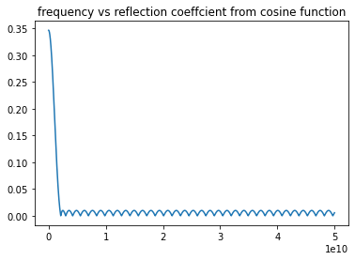

**RESULTS AND DISCUSSION:**

Klopfenstein tapper has been designed using Jupyter and its behaviors are studied

**CONCLUSION:**

In conclusion, the Klopfenstein tapper is a simple yet effective passive device that plays a crucial role in improving the efficiency of microwave energy transfer in high-power applications. The careful design, material selection, surface finish, and precise placement are important considerations in making the tapper in a lab setting to achieve optimal results.

**ABOUT THE COMPONENTS USED**

Juyter Notebook

Jupyter Notebook is an open-source web application that allows users to create and share documents containing live code, equations, visualizations, and narrative text. It is a powerful tool for data analysis, machine learning, and scientific computing, providing a flexible and interactive environment for programming in various languages.